**DAILY ONLINE ACTIVITIES SUMMARY**

|  |  |  |  |  |  |  |  |  |
| --- | --- | --- | --- | --- | --- | --- | --- | --- |
| **Date:** | **08-06-2020** | | | | | **Name:** | **Anusha** | |
| **Sem & Sec** | **VIII Semester & A Section** | | | | | **USN:** | **4AL16CS014** | |
| **Online Test Summary** | | | | | | | | |
| **Subject** | | **SMS** | | | | | | |
| **Max. Marks** | | **60** | | **Score** | | | **60** | |
| **Certification Course Summary** | | | | | | | | |
| **Course** | **Introduction to Hadoop & Robotic Process Automation** | | | | | | | |
| **Certificate Provider** | | | **Great Learning & Ui Path** | | **Duration** | | | **4 Hours & 3 Hours** |
| **Coding Challenges** | | | | | | | | |
| **Problem Statement: Generate all set partitions of n numbers beginning from 1 to so on.** | | | | | | | | |
| **Status: COMPLETED** | | | | | | | | |
| **Uploaded the report in Github** | | | | | **YES** | | | |
| **If yes Repository name** | | | | | **anushasuvarna-14** | | | |
| **Uploaded the report in slack** | | | | | **YES** | | | |

Online Test Details:



Certification Course Details:

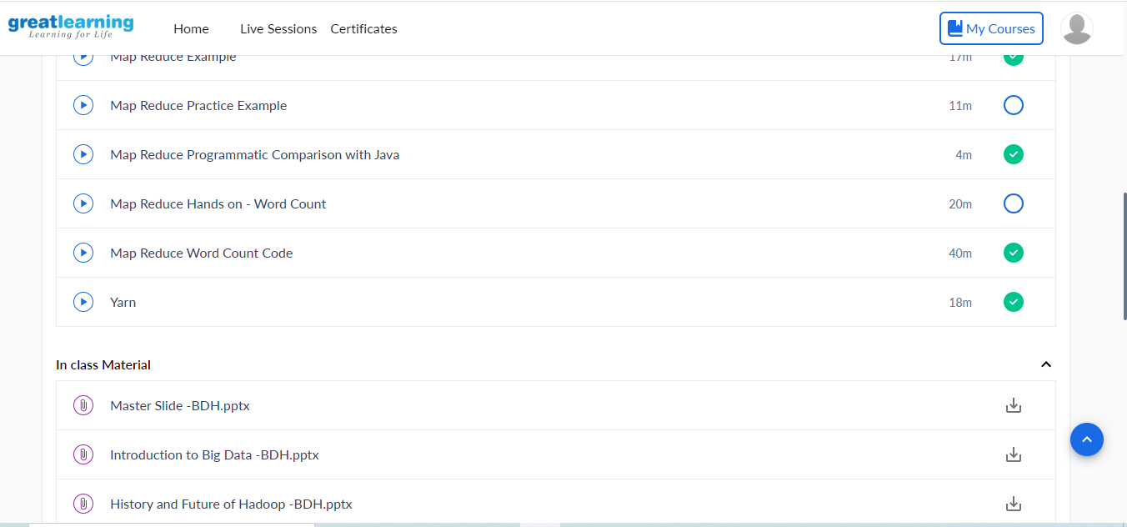

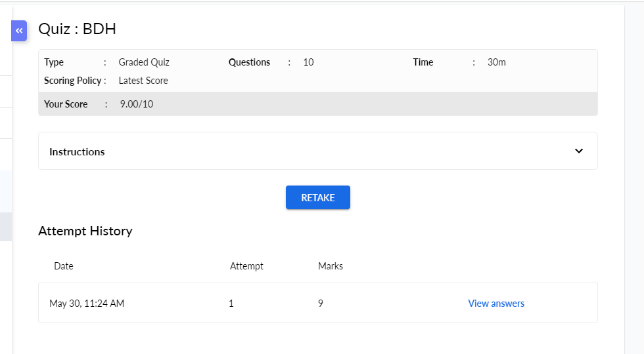

Coding Challenges Details:

**Program1:**

|  |
| --- |
| **#include<stdio.h>** |
|  |  |
|  | **void printArray(int p[], int n)** |
|  | **{** |
|  | **for (int i = 0; i < n; i++)** |
|  | **printf("%d ",p[i]);** |
|  | **printf("\n");** |
|  | **}** |
|  |  |
|  | **void partition(int n)** |
|  | **{** |
|  | **int p[n], true=1;** |
|  | **int k = 0;** |
|  | **p[k] = n;** |
|  |  |
|  | **while (true)** |
|  | **{** |
|  | **printArray(p, k+1);** |
|  |  |
|  | **int rem_val = 0;** |
|  | **while (k >= 0 && p[k] == 1)** |
|  | **{** |
|  | **rem_val += p[k];** |
|  | **k--;** |
|  | **}** |
|  |  |
|  | **if (k < 0) return;** |
|  |  |
|  | **p[k]--;** |
|  | **rem_val++;** |
|  |  |
|  | **while (rem_val > p[k])** |
|  | **{** |
|  | **p[k+1] = p[k];** |
|  | **rem_val = rem_val - p[k];** |
|  | **k++;** |
|  | **}** |
|  |  |
|  | **p[k+1] = rem_val;** |
|  | **k++;** |
|  | **}** |
|  | **}** |
|  |  |
|  | **int main()** |
|  | **{** |
|  | **int n;** |
|  | **printf("Enter the number: ");** |
|  | **scanf("%d",&n);** |
|  | **partition(n);** |
|  |  |
|  | **return 0;** |
|  | **}** |